Bowling Green or Bust

Yeah…..we made it!

Wine Tasting Party



Wednesday August 27, 2014 – Holiday Inn Atrium – 5:30 PM

Though the State‘s bourbon industry may receive most of the hype, Kentucky has certainly played an important hand in the history of wine in the U.S. Did you know Kentucky was home to the first commercial vineyard in the country? Or, that Kentucky wineries once produced more than 50 percent of the United States’ grape harvest and wine yield? Join us as we sample some of the local Favorites.

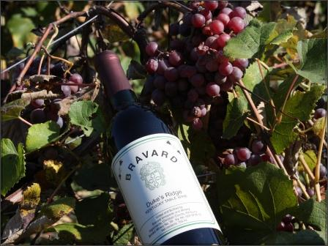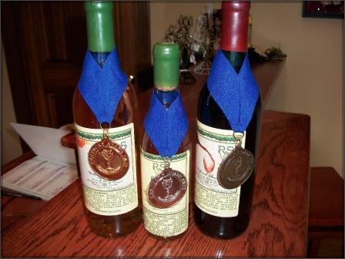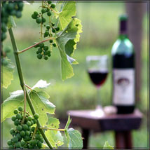

Price for wine tasting is TBA per person e-mail [vetteflock@cox.net](mailto:vetteflock@cox.net)

with Cheese and Crackers



Please Remember to Drink and Drive Responsibly

Just one more please!